**Prerequisite software:**

1. SQL Developer Edition

<https://www.microsoft.com/en-in/sql-server/sql-server-downloads>

1. SQL server management studio (SSMS)

<https://learn.microsoft.com/en-us/sql/ssms/download-sql-server-management-studio-ssms?view=sql-server-ver16>

1. Power Bi report server

<https://www.microsoft.com/en-us/download/details.aspx?id=105944>

1. Power Bi RS version

<https://www.microsoft.com/en-us/download/details.aspx?id=105944>

Download and install the latest version using the given links

**Step 1**: Open SSMS and connect using windows Authentication

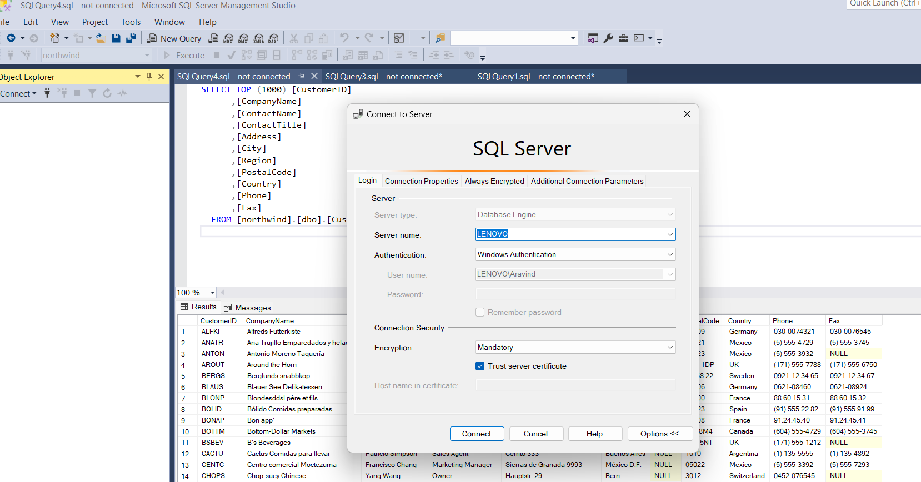

**Step 2** : Double click on the security folder and inside that expand the logins

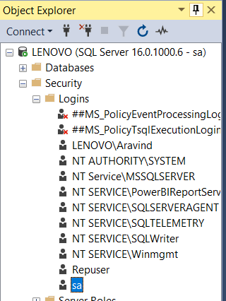

**Step 3**: click on sa user and change the password

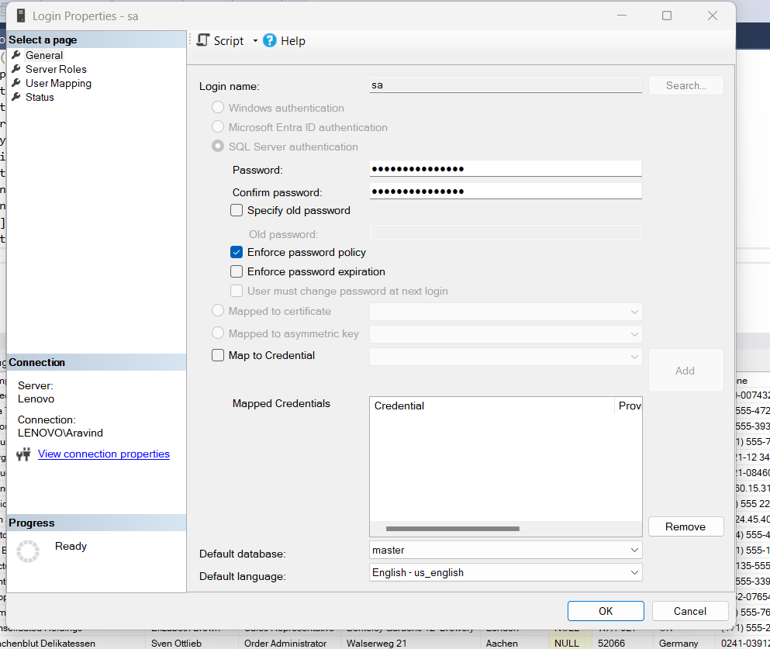

**Step 4:** click status page and select the Enabled radio button for login

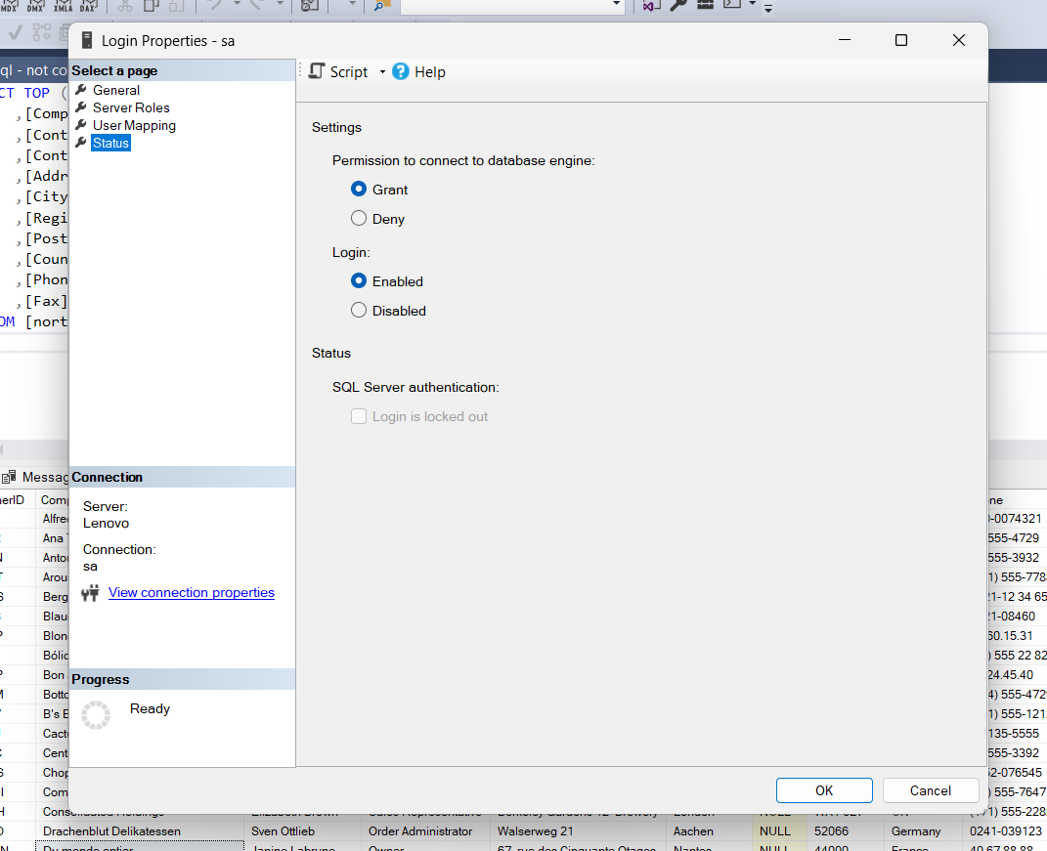

**Step 5** – Open Database Properties

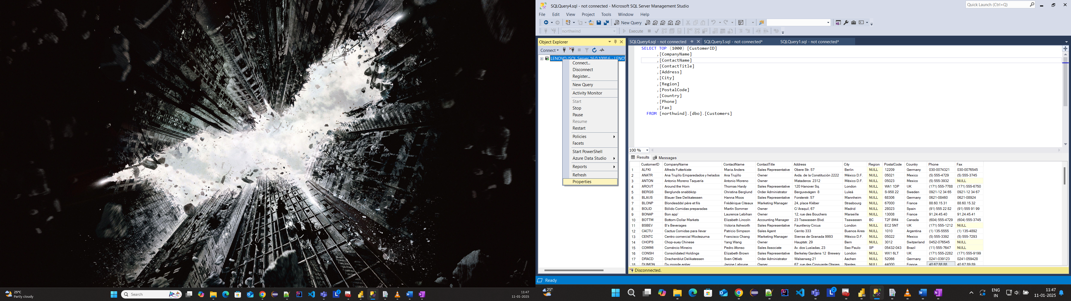

**Step 6**- Change the server authentication to SQL server and Windows Authentication mode

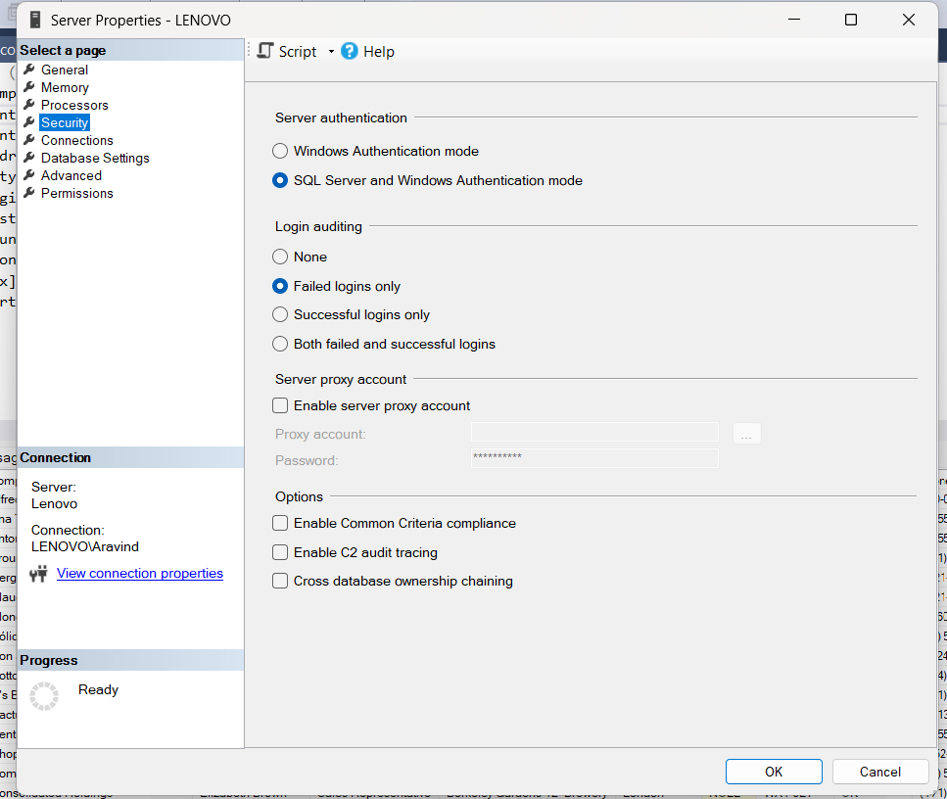

**Step 7**– Disconnect the database

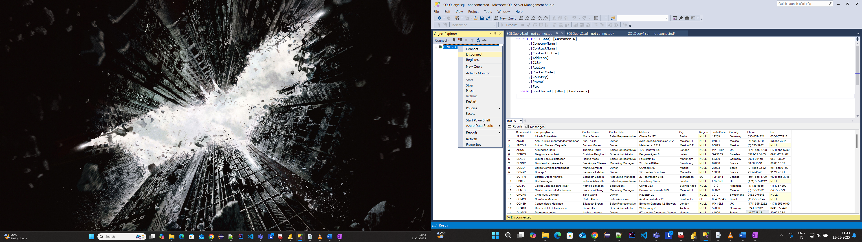

**Step 7**- connect database using SQL server authentication with sa user credentials

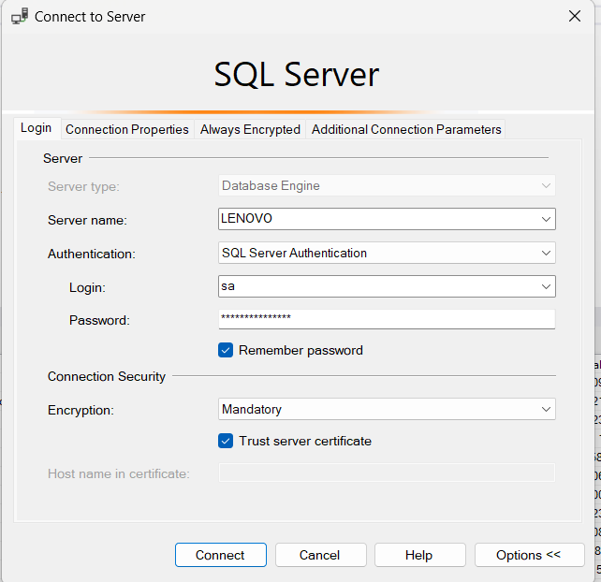

**Report Server configuration**

**Step 1**: Open Report server configuration manager and connect

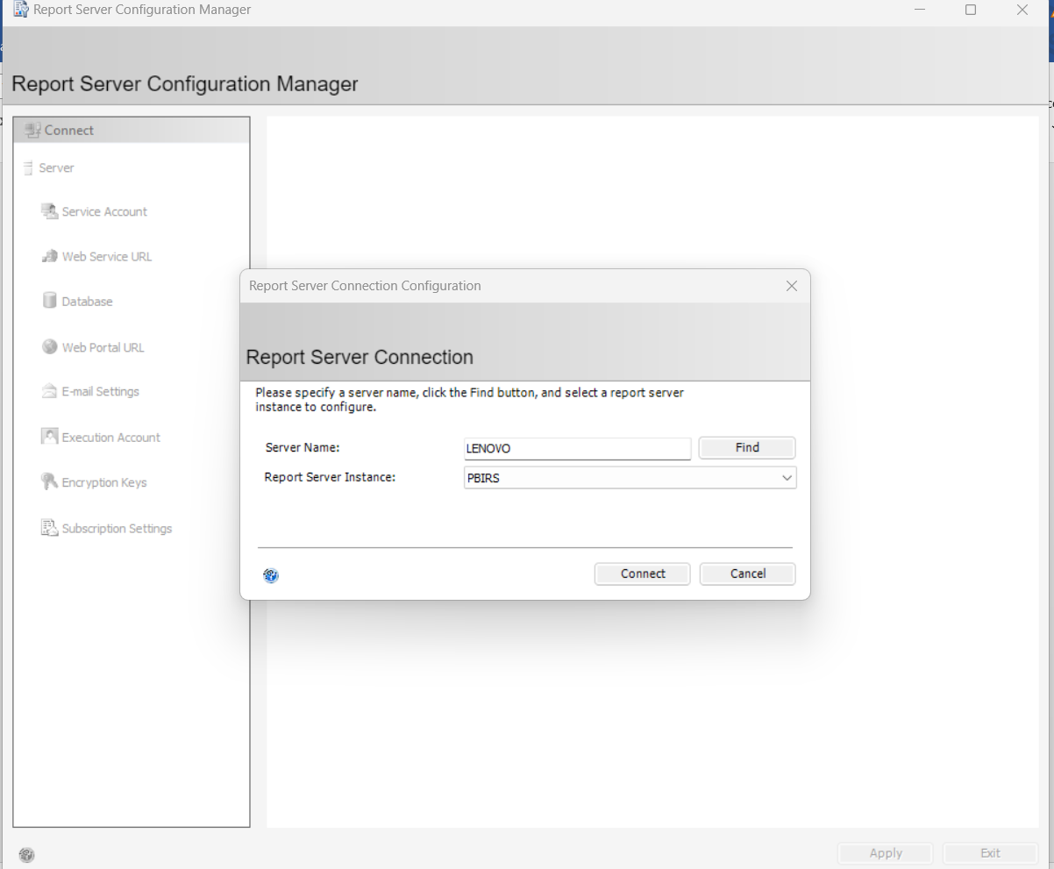

**Step 2**- click on Database and configure by clicking change database

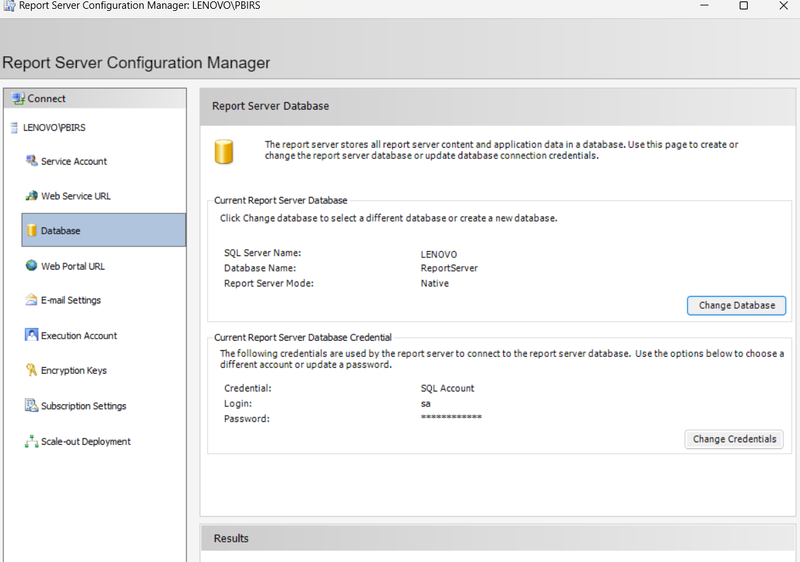

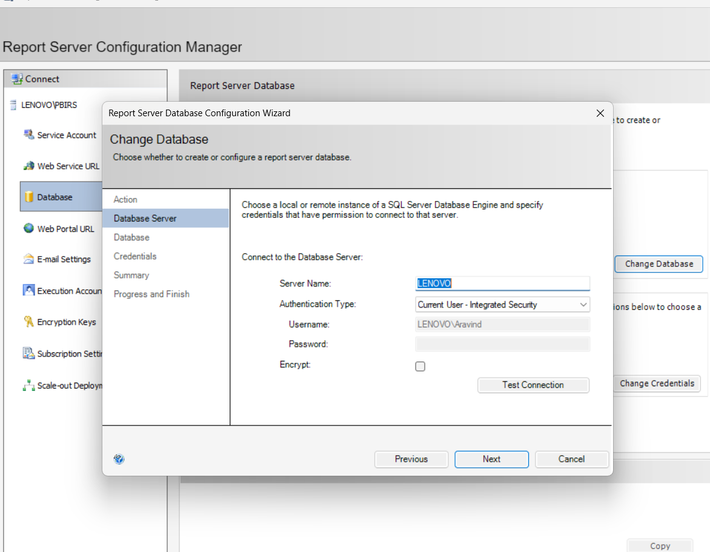

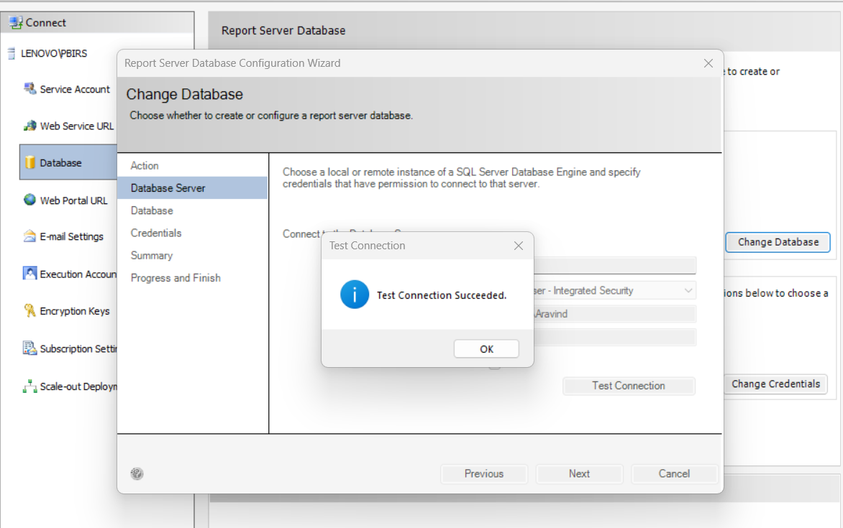

Change the Authentication type to SQL server credentials and enter the sa user credentials

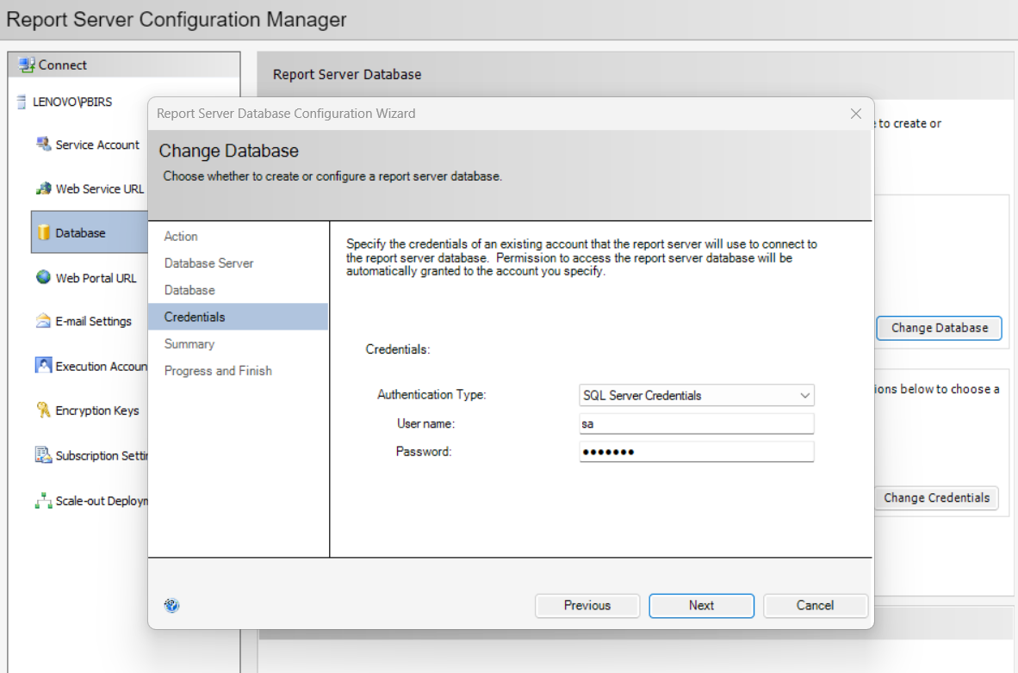

Click on finish

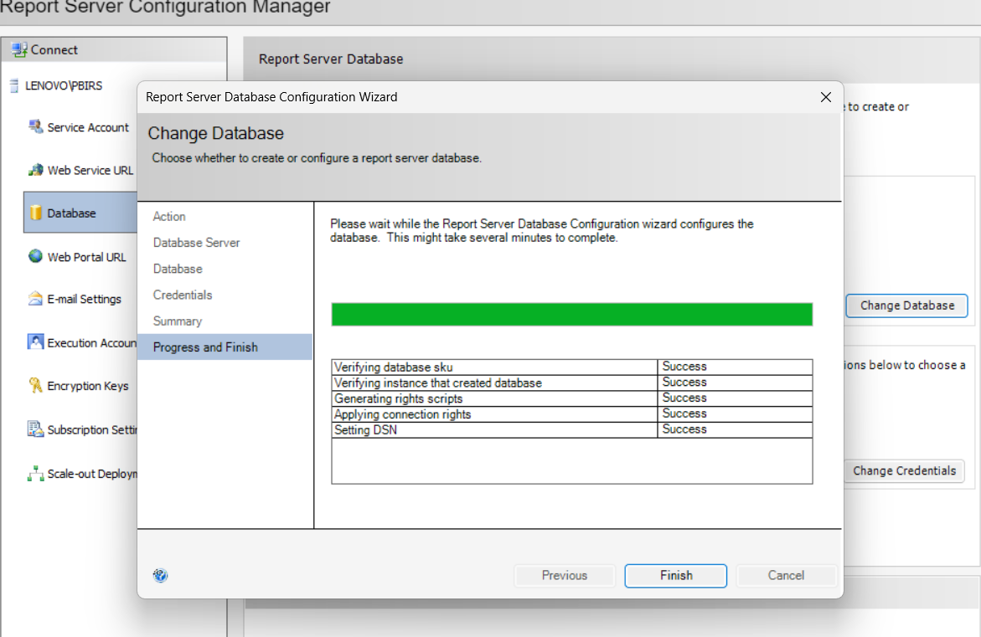

**Step 3** – Go to Web Portal URL and hit the Web Portal URL

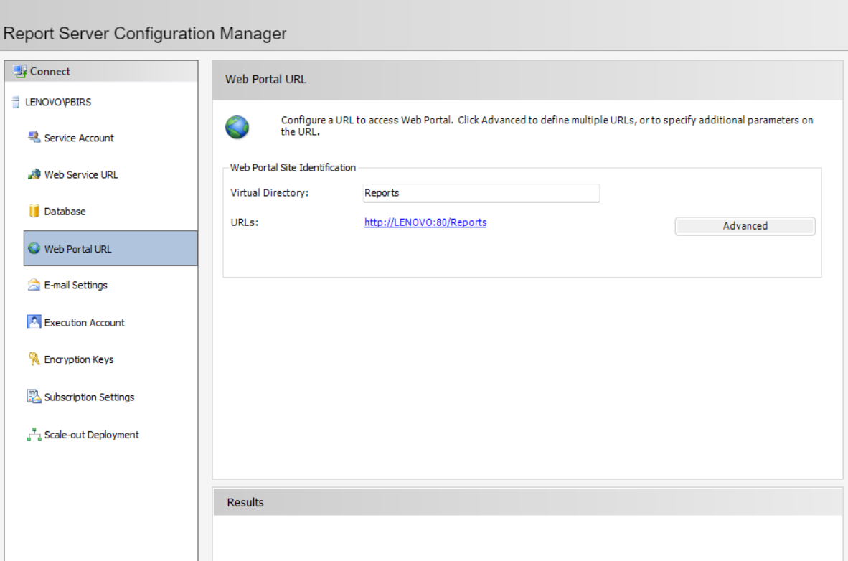

URL:

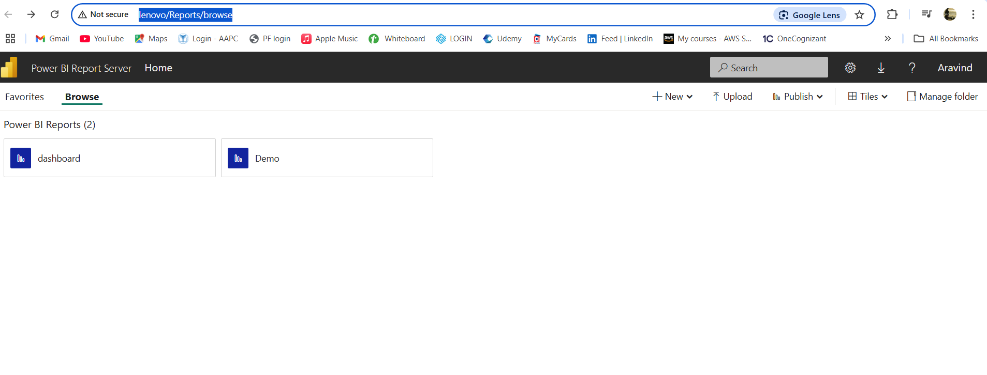

**Create a Sample table in SSMS:**

**Step 1:** Create a database using the below shown query

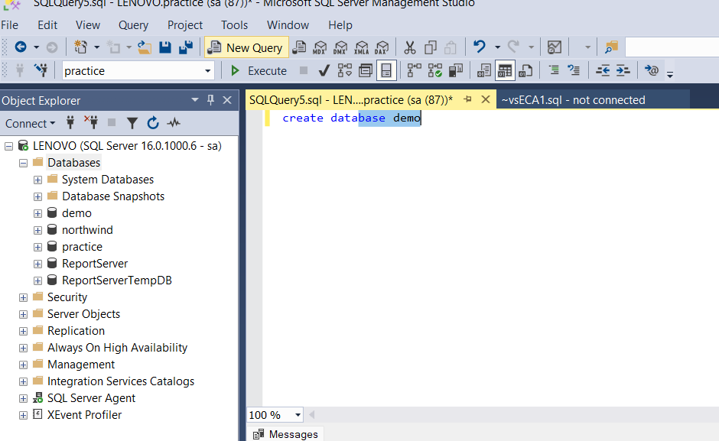

**Step 2:** Create a schema inside the demo database query

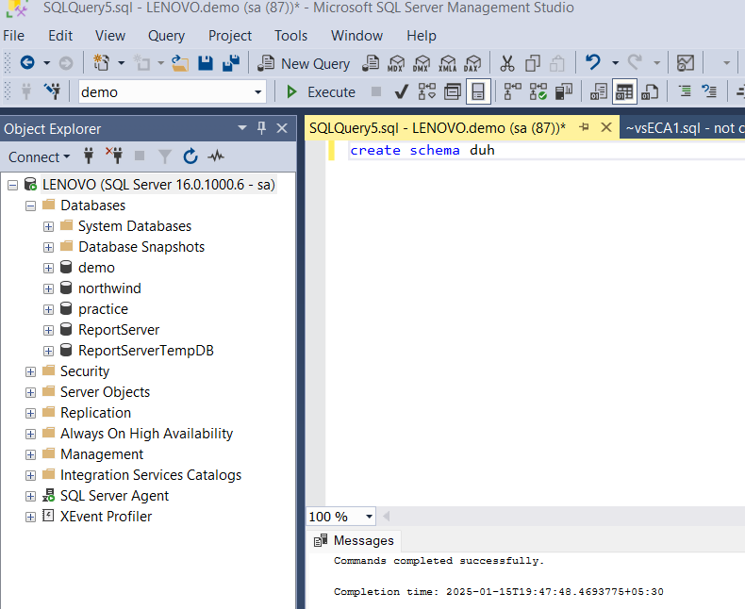

**Step 3**- Create a sample table

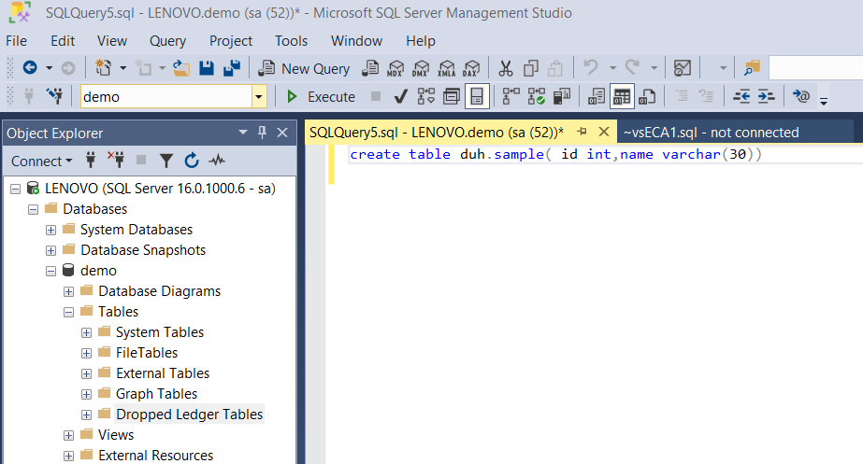

**Step 4**: Insert values to the sample table

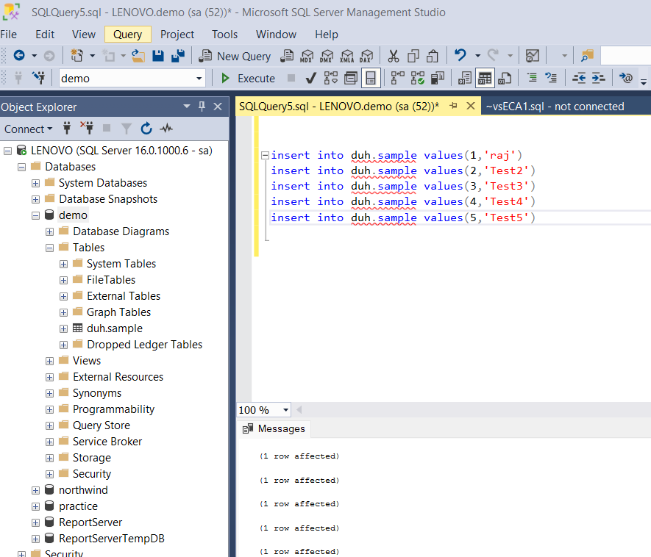

**Step 5**: View the created sample table using select query

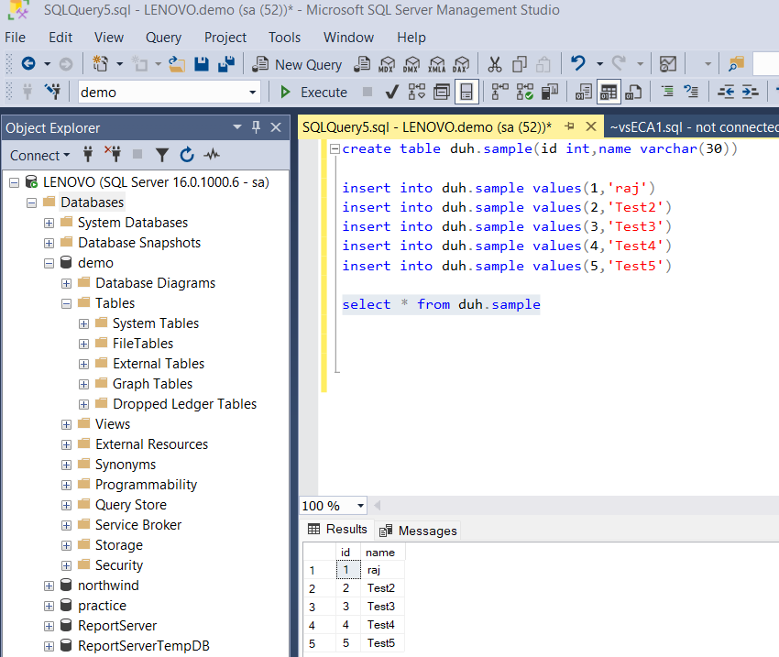

Importing sample data in Power BI rs version

**Step 1**: Open Power BI rs version and click on import data from sql server

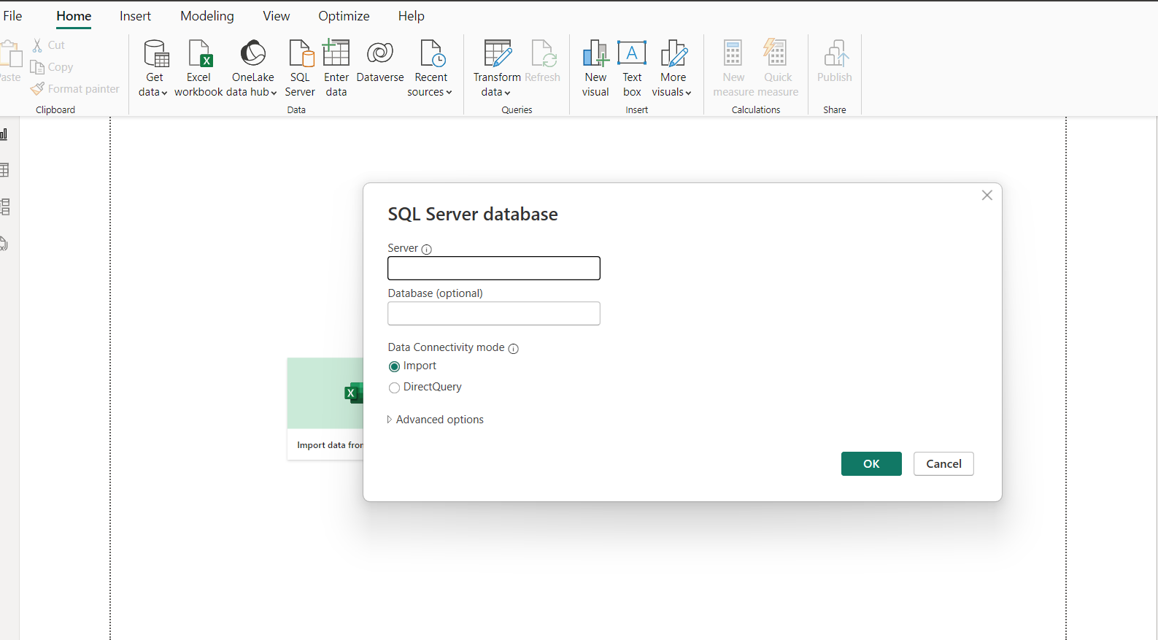

**Step 2** : Enter Server name, Database and click on ok

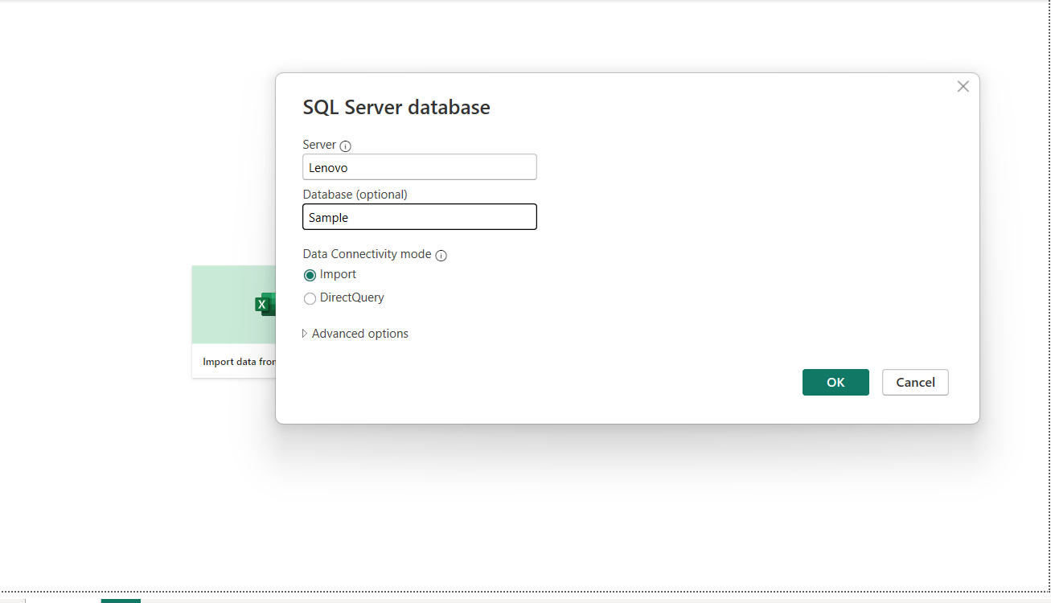

**Step 3**: click on database tab and enter the sa user credentials

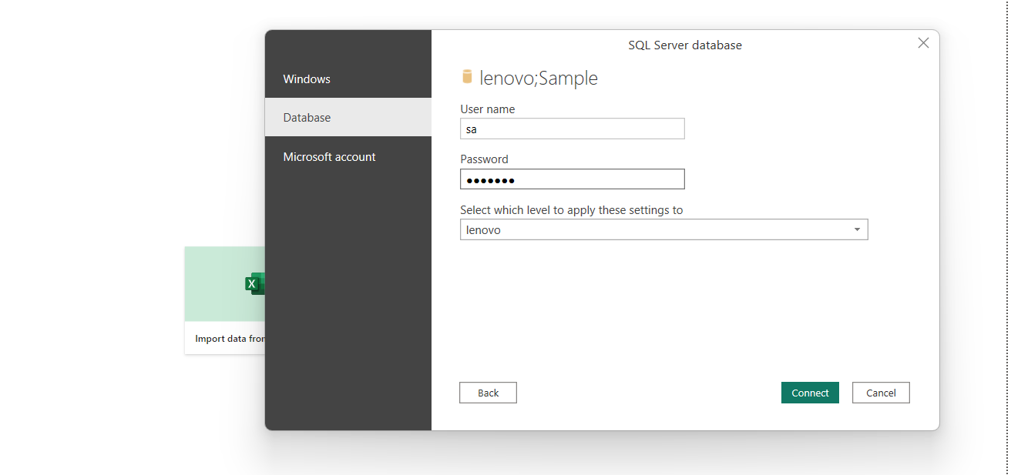

**Step 4**: Load the data

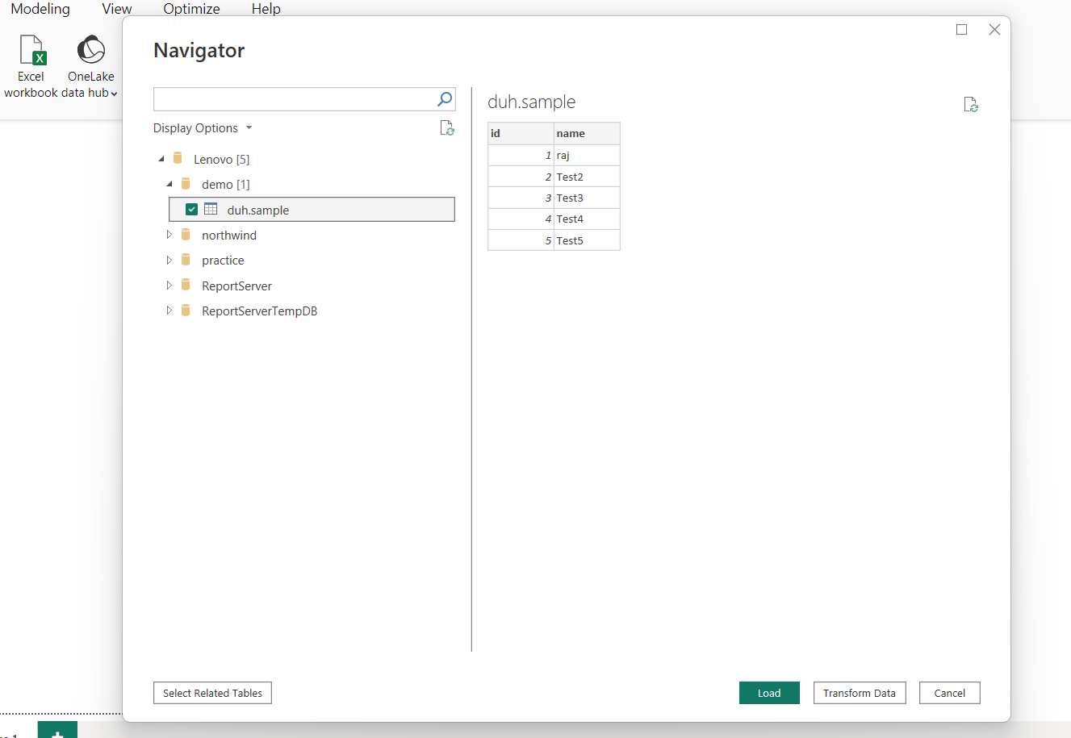

**Step 5:** Create a table in Power Bi

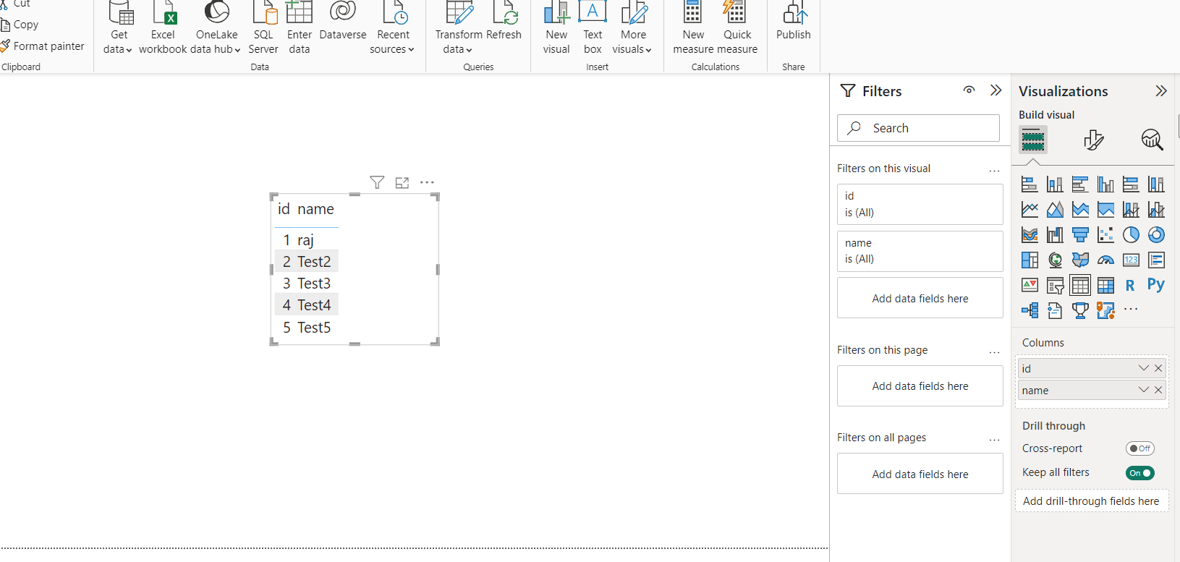

**Step 6**: Save as power Bi Report server

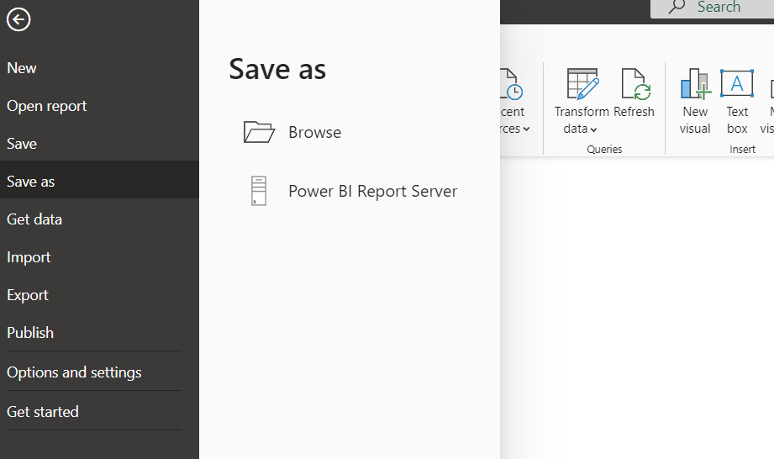

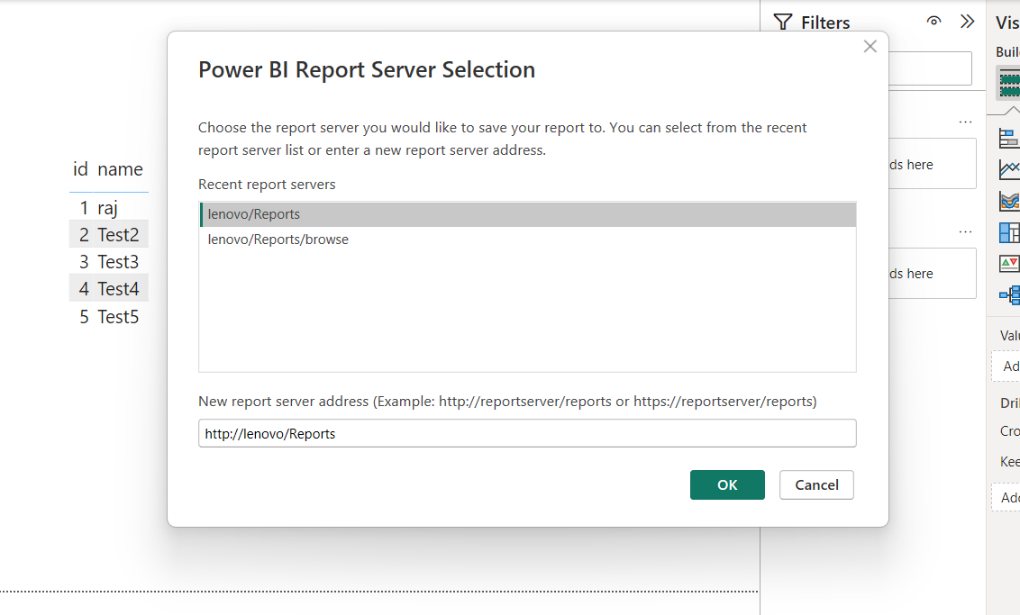

Save the file

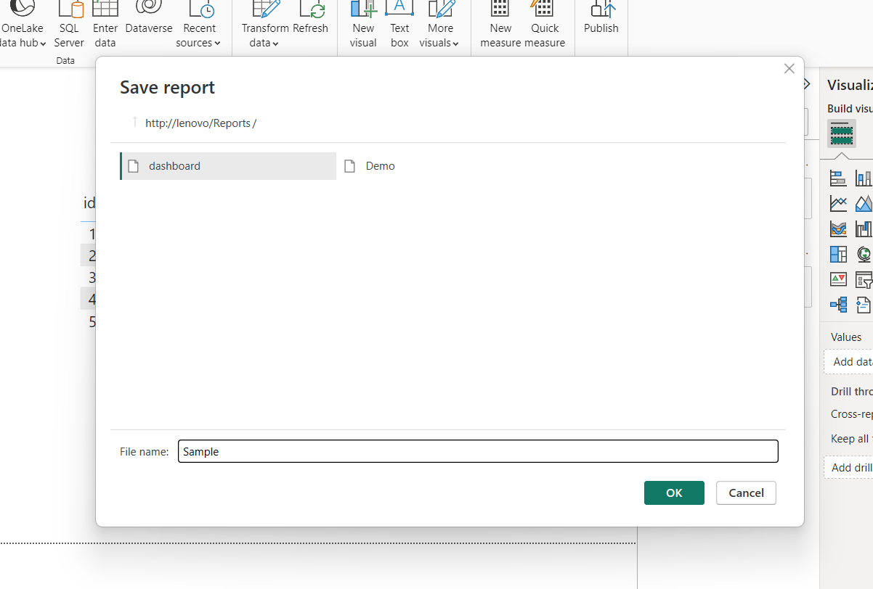

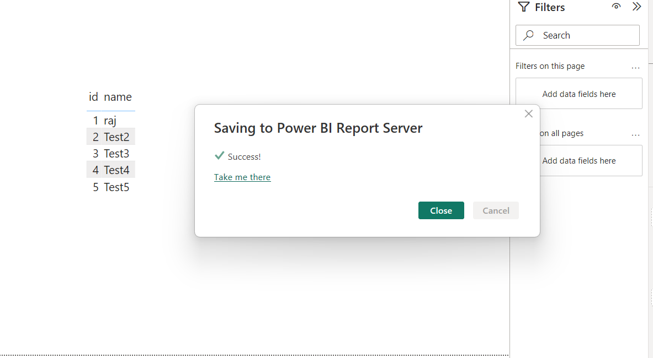

**Step 7**: click on take me there or open report server URL

